**Artifical Intelligence**

**Assignment 4**

**L17-4284-C**

**L17-4365-C**

**Cost vs Iteration Graph (when training and testing size = 75):**

Cost at iteration 0: 127.00000000000001

Cost at iteration 100: 58.53620373266883

Cost at iteration 200: 30.00670722541134

Cost at iteration 300: 17.06920747062354

Cost at iteration 400: 10.673428042672676

Cost at iteration 500: 7.264070536398072

Cost at iteration 600: 5.337981432726219

Cost at iteration 700: 4.203286670778914

Cost at iteration 800: 3.5138219910166484

Cost at iteration 900: 3.083876925831679

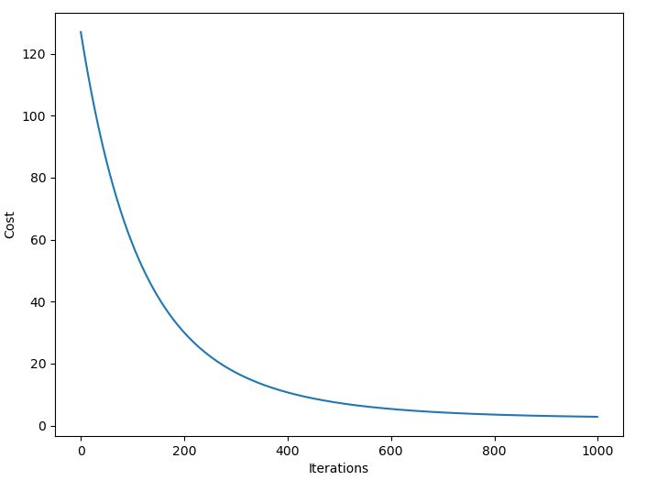

**Problems of not using step function:**

Activation functions add a non-linear property to the neural network. This way the network can model more complex data. Furthermore, step functions also help in predicting a clear output giving smooth gradients and normalizing the outputs. If we don’t use activation function it would be difficult to predict and classify the dataset in classes.

**Effect of rounding off and applying step function on test set:**

By rounding off the value of yhat and applying step function the error rate on test set significantly reduces, since it became easier for the function to classify the dataset based on its features.

**Cost vs Iteration Graph(when training and testing size = 100, 50):**

Cost at iteration 0: 179.0

Cost at iteration 100: 73.62437264869133

Cost at iteration 200: 35.97322809185651

Cost at iteration 300: 20.346742945122042

Cost at iteration 400: 12.83601009742828

Cost at iteration 500: 8.806165090499874

Cost at iteration 600: 6.492010705106169

Cost at iteration 700: 5.1104795709761115

Cost at iteration 800: 4.265534469356379

Cost at iteration 900: 3.73853146672007

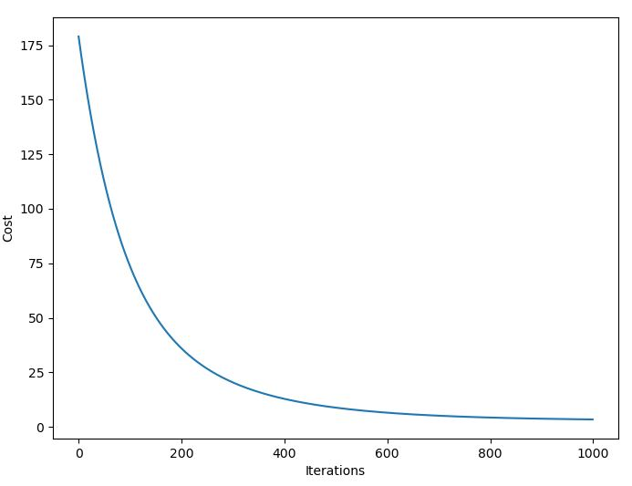

The cost of training phase is increased when the size of training set increases, but the overall shape of the graph remains the same.